**THE UNIVERSITY OF NORTHAMPTON**

**(NAMI COLLEGE)**

**Report for web (Term 1)**

NAME: MILAN SHRESTHA

UN ID: 16418532

**CONTENTS: pages**

1. Getting started 3
2. Designs 3

2.1 Sketches 3

2.1.1 Sketch for home page 4

2.1.2 Sketch for biography page 5

2.1.3 Sketch for CV page 6

2.1.4 Sketch for contact page 7

2.1.5 Sketch for mobile responsive 8

3. Final designs 10

3.1 Home page for desktop 10

3.2 Biography page for desktop 10

3.3 CV page for desktop 11

3.4 Contact page for desktop 11

* 1. Final mobile view 12

1. Working progress
2. Conclusion
3. Reference

1. **Getting Started**

First of all, honestly before starting to create my portfolio, I visited different web pages and got some ideas from them to style my portfolio. I got a lot of ideas and concept from these pages and found that people has used like HTML5 or Bootstrap. So, as in our assignment information has told us to use HTML5 so I have used HTML5 to build my web page. CSS is being used to style the page. It has completely helped me to create my own creation and design them in the way I like to do. HTML5 is a great platform to work on. So, I decided to make four pages and firstly I starts with wireframe sketches and made a design to work on. I style all pages of my website in a single CSS.

1. **Designs**

**2.1 Sketches**

2.1.1 Sketch for homepage

Navigation bar is the one of the important part of the web page so, I wanted to keep navigation bar as a header on my web page and inside this bar there is logo division and menu bar which transfers us to different page of my web site. Logo is at the left side of the whole bar and menu at the middle and search at the left side. Again inside navigation bar there is another search division and its button. When we hover in the menu section it shows different colour.

Below the navigation bar there is photo and some welcome message and background is kept on that section. The welcome massage has some animation.

Finally, at the footer part there is two division. One division is for the icons with the link about the icon and the other section is for the copyright part.

The navigation bar and the footer part is same for all the pages in my web site.

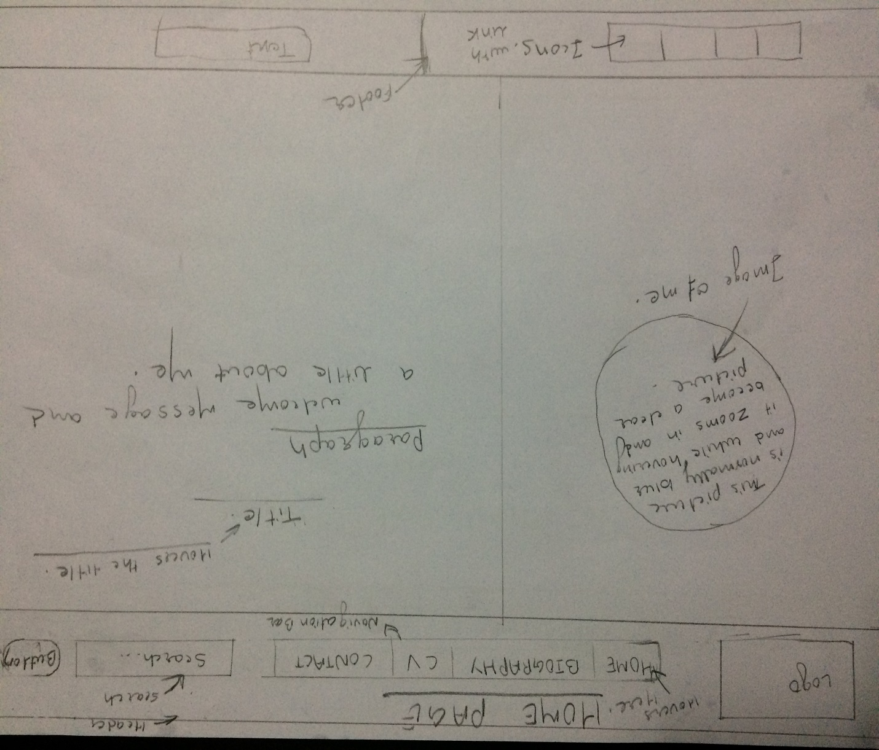

2.1.2 Sketch for biography page

For my biography page I have kept same navigation bar and same footer as of the home page. I have included something about me and at the side of the about me there is photo of me. This photo rotates in 180 degree and a little opacity is kept in that photo.

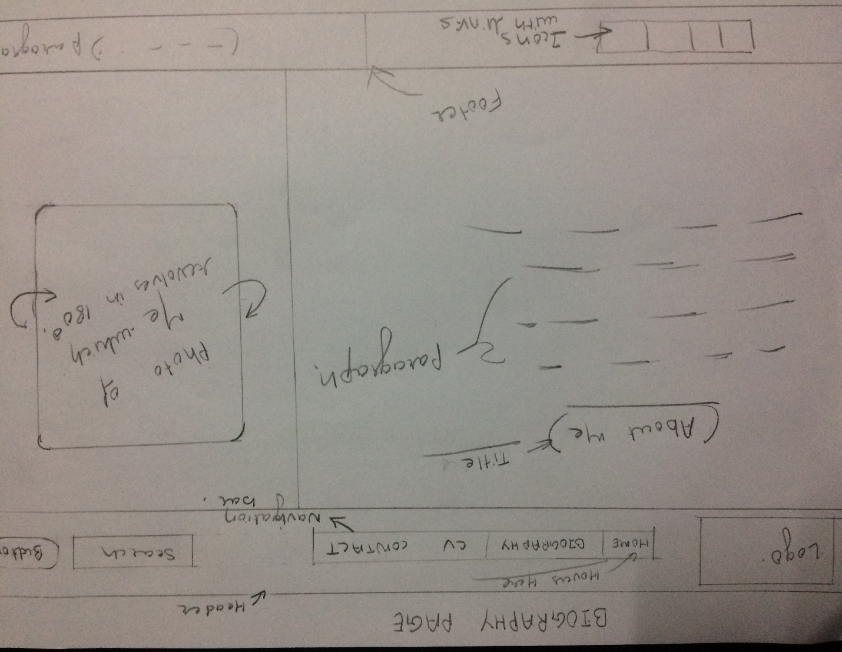

2.1.3 Sketch for curriculum vitae (CV) page

The navigation bar and the footer part is same as the home page. Inside the body part there are three divisions in the first left side division there is personal details of me and in the right side division there is my education detail, my skills and my experience. In the top division there is header and my name is written there.

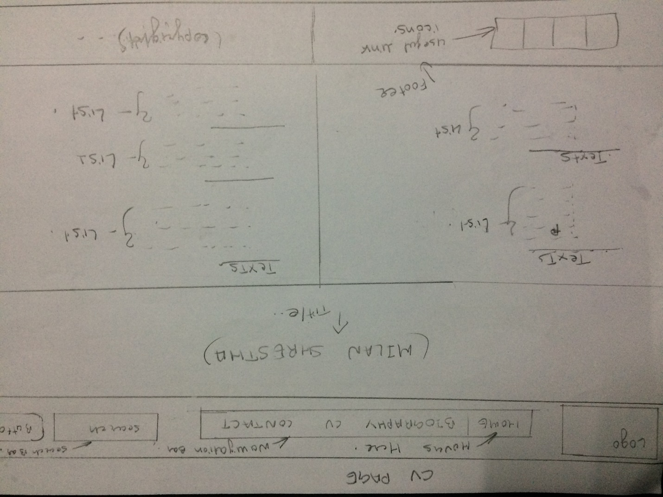

2.1.4 Sketch for contact page

In this contact page same navigation bar and footer is kept as of the home page. Inside the body there is section and in section there is three division one division is for form to send emails and contact me, second division is for my phone number and email address, and last division is for my photo as shown in the picture below.

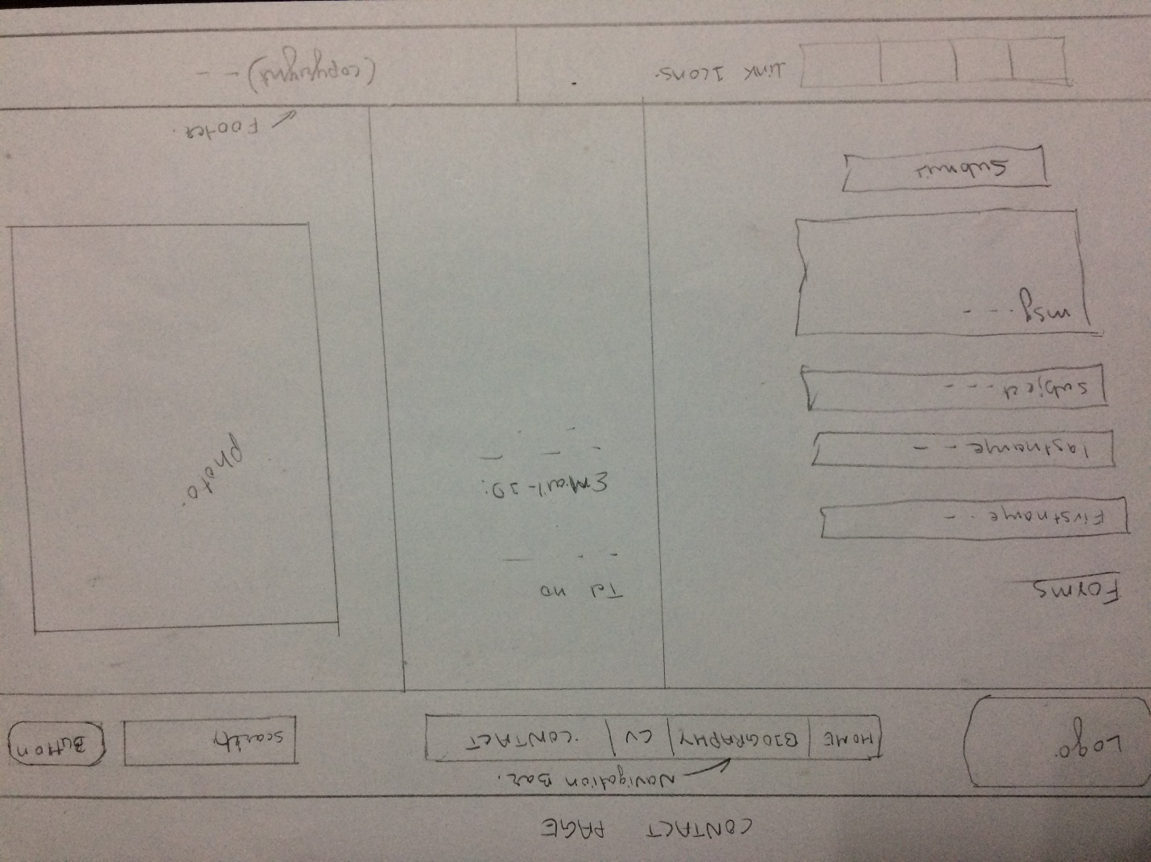

**2.1.5 Sketch for mobile responsive**

In the mobile responsive page all the header, body and footer part which were in row form all becomes the column form. All the division are set to be in column. All the header and footer are same for the all pages. Some 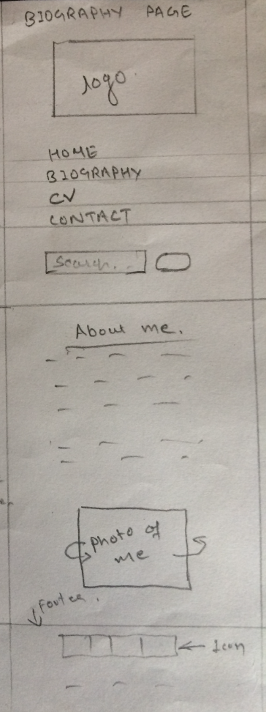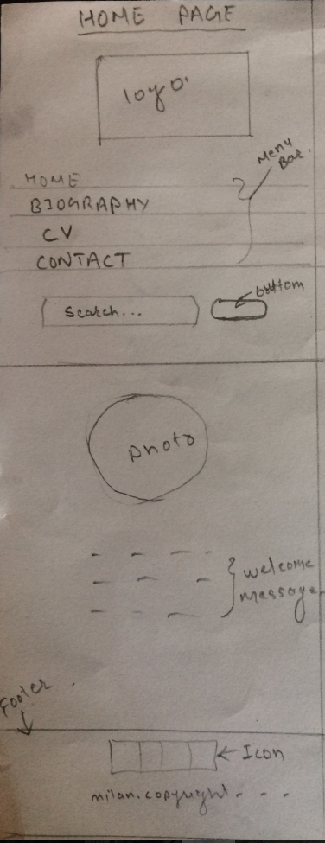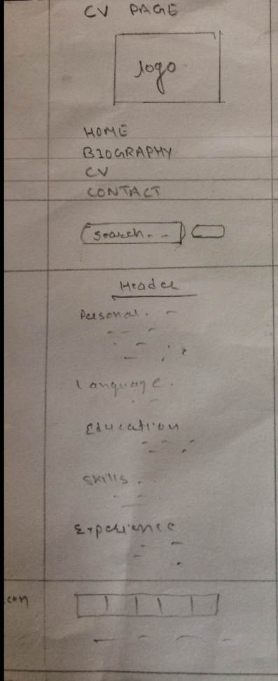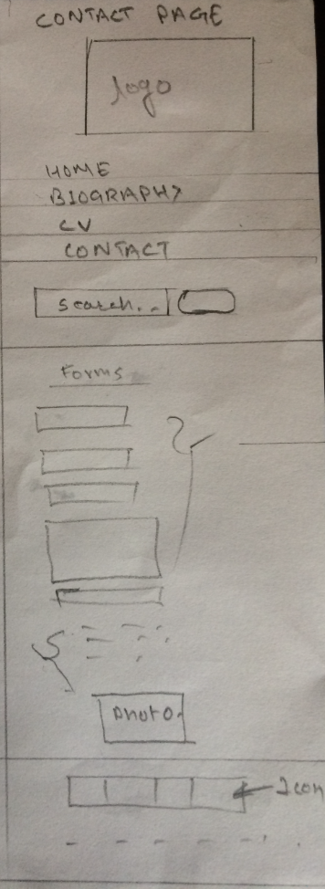

1. **Final web Designs**

In this final web design I am satisfied with my design. These designs are same as the sketches above. At the footer part there is some useful icons with the link and in navigation bar there are menu search and logo.

**3.1 Homepage for Desktop**

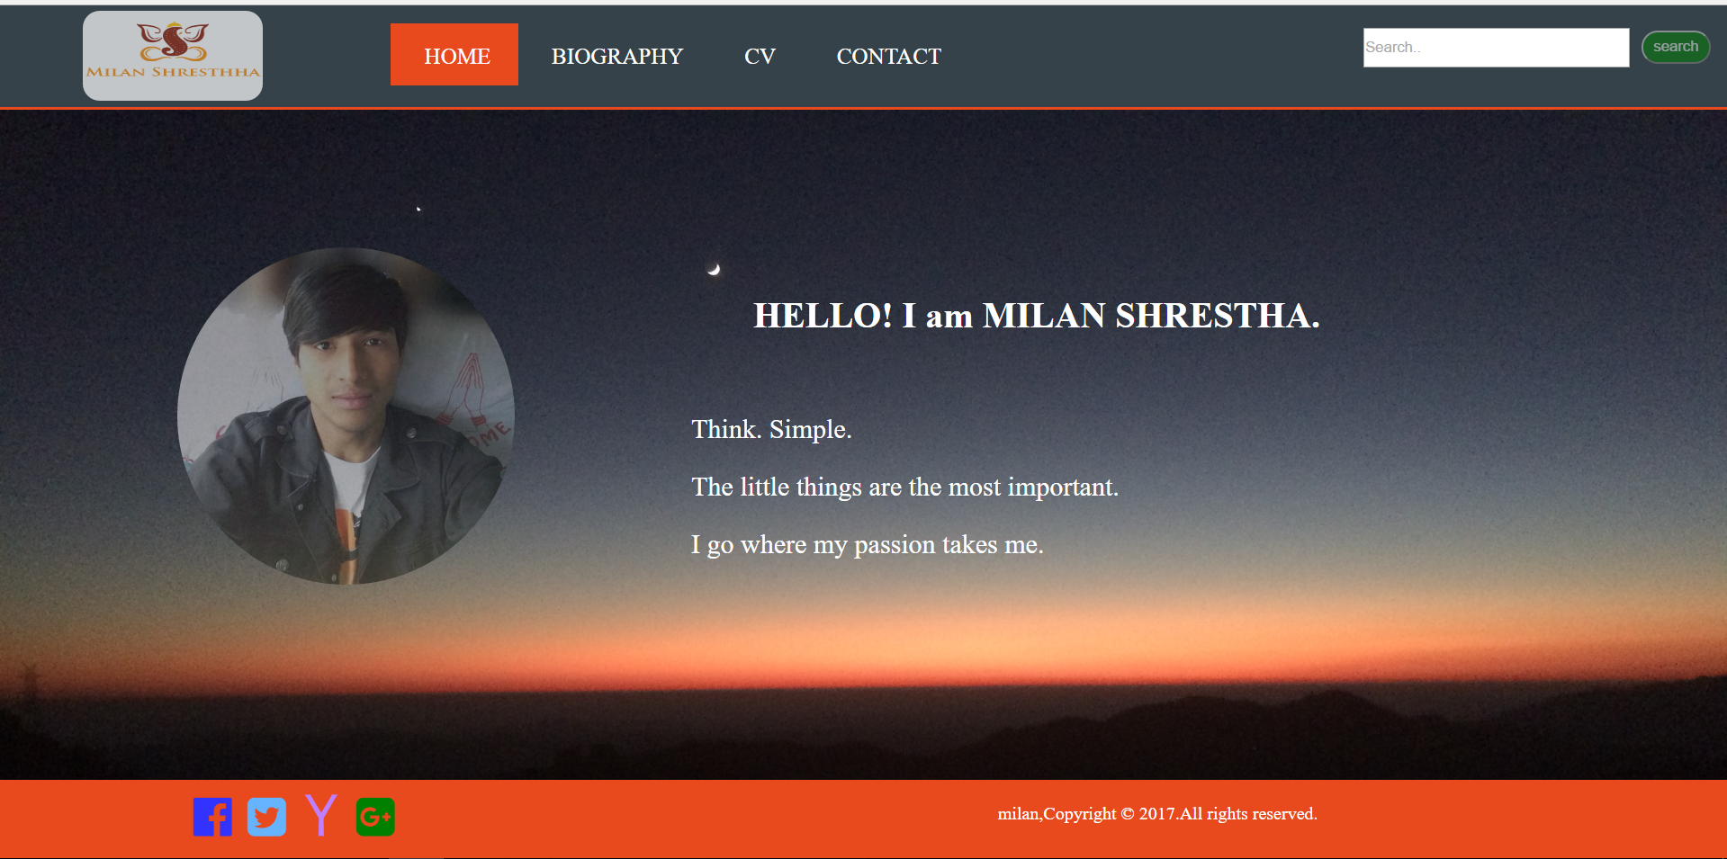

**3.2 Biography page for desktop**

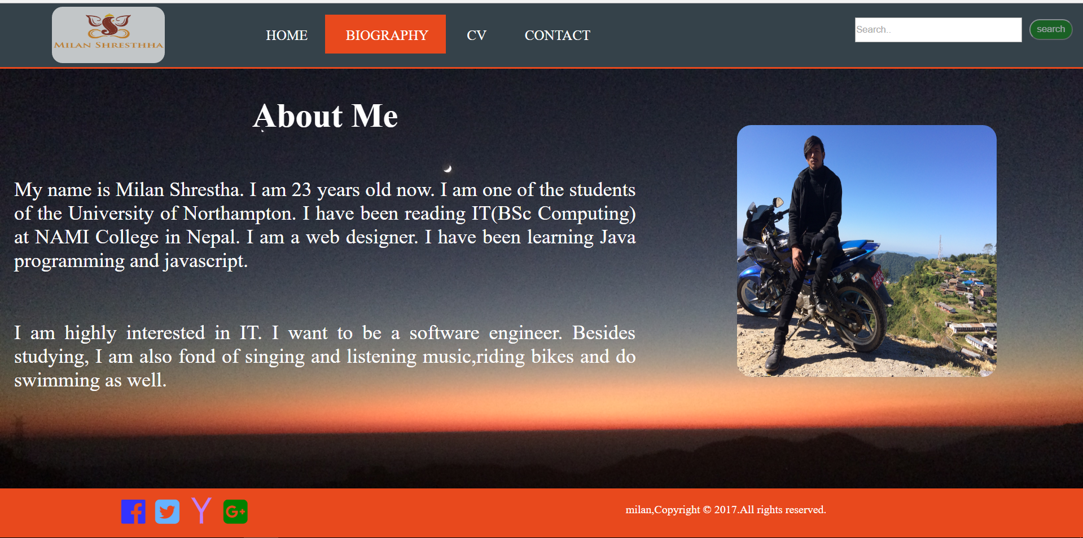

**3.3 CV page for desktop**

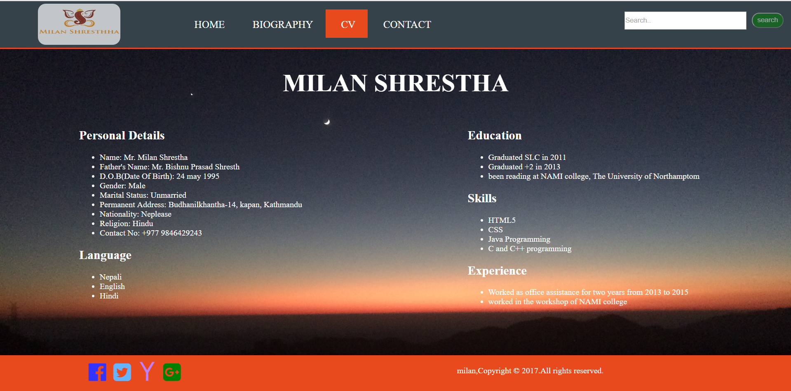

**3.4 Contact page for desktop**

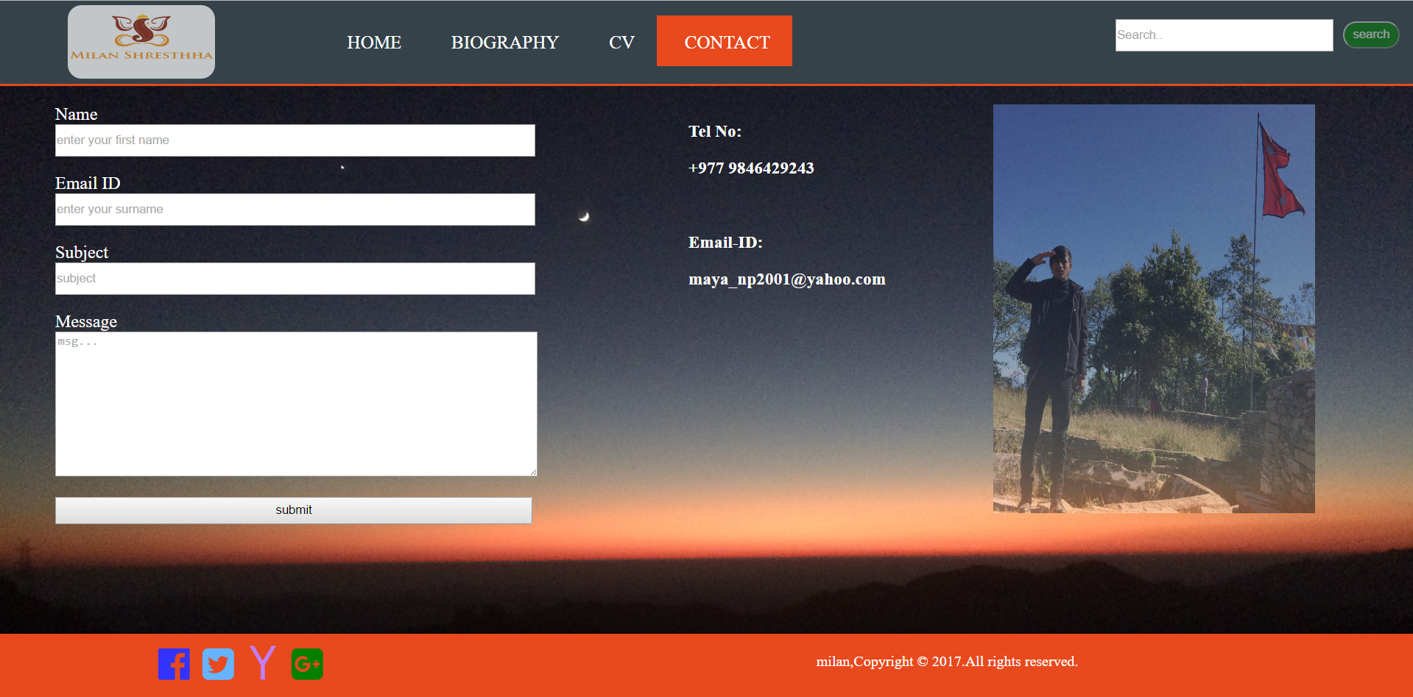

**3.5 Final Mobile View**

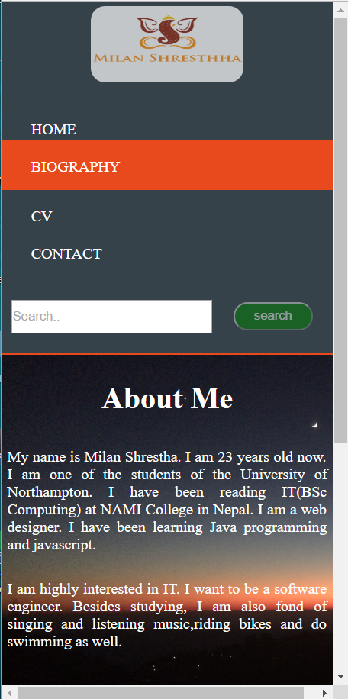 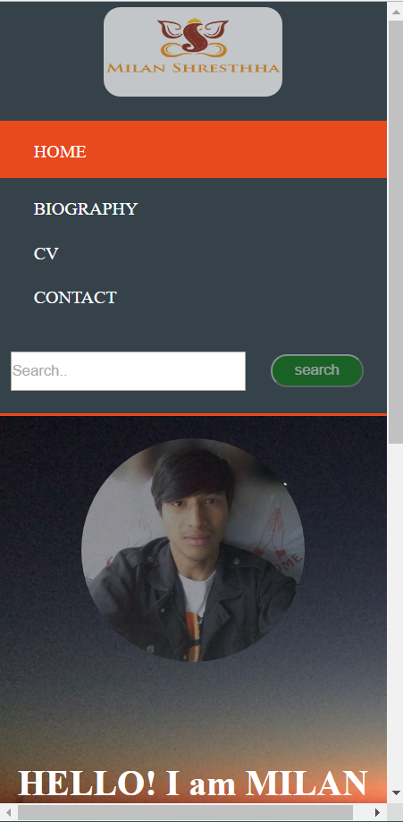

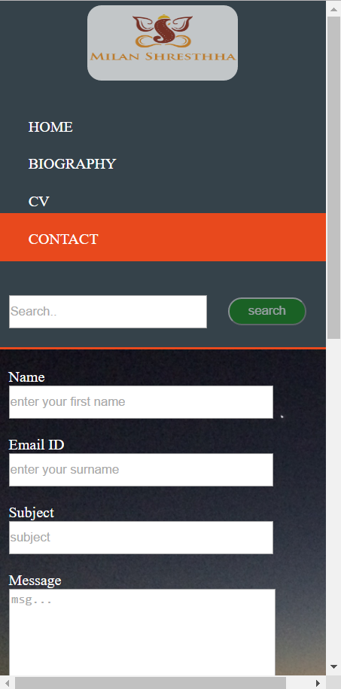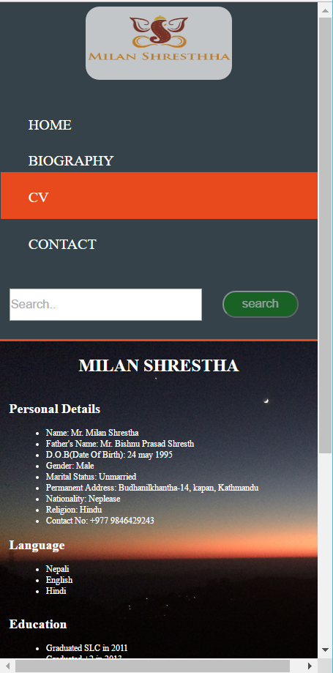

1. **Working Progress**

In the working progress